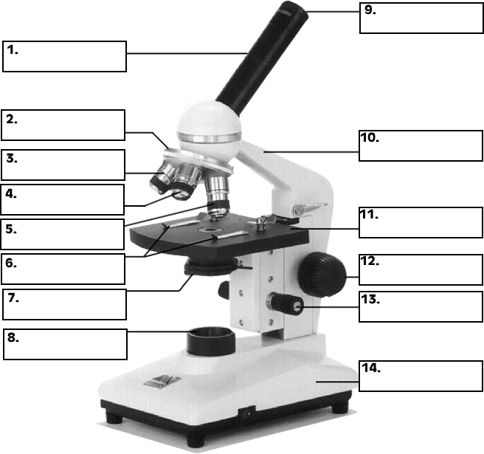
Directions: Be able to label each part of a microscope below. Additionally, you must know how each part functions.
Key Tips and Usage Guidelines:
1.
2.
3.
4.

Another copy….for practice.

