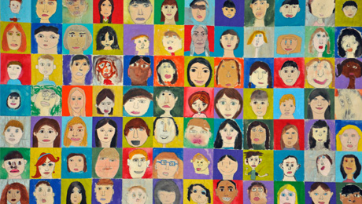
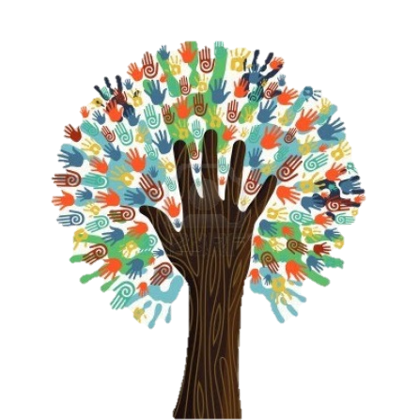
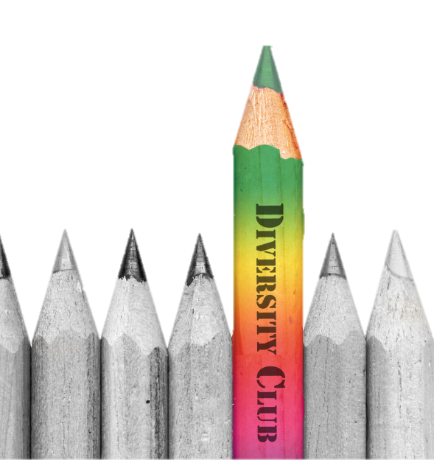
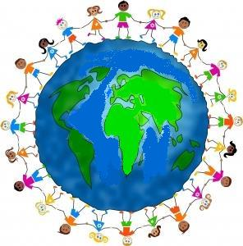

http://mus-iq.com/Small-World-Workshop.aspx
http://richincolor.com/2013/10/what-i-mean-when-i-talk-diversity/
http://goaupairphiladelphia.wordpress.com/2013/07/01/how-the-au-pair-can-enlighten-a-family-about-culture-exchanges/
http://theyouthcartel.com/2013/kingdom-diversity/
http://www.okpta.org/2014/01/13/membership-monday-diversity-and-inclusion-in-your-pta/
http://www.dreamstime.com/illustration/diversity.html
http://www.brownsburg.k12.in.us/bhs/Clubs_Organizations/diversityclub/Home.htm
http://www.mckendree.edu/offices/provost/assessment/current-assessment-activities.php
http://www.pdx.edu/diversity/home
http://schools.smcps.org/lhs/featured/297-diversity-equity
http://www.carlospagan.com/portfolio/bill-bernbach-diversity-scholarship-posters/39

