http://vector-magz.com/signs-symbols/handicap-signs-item-4/ (handicap)
http://www.jamesallen.com/education/engagement-rings/how-to-pick-your-ring.html (ring)
http://www.daisygreenmagazine.co.uk/beauty/features-beauty/skin-care-through-the-ages/ ( age)
http://fmhvibe.co.uk/index.php/index.html/_/fmh2011/2011guides/picking-a-nationality-r138 (nationality)
http://www.alderkoten.com/institute/2013/10/diversity-recruiting-recruiting-diversity/ (skin color)
http://ego.thechicagoschool.edu/s/843/index.aspx?sid=843&gid=3&pgid=61&cid=121 (world with hands)
http://www.learnvest.com/2013/01/7-money-links-we-love-the-100-richest-people-could-end-poverty/ (money)
http://empoweringldswomen.blogspot.com/2011/10/birth-control-and-family-planning.html (famiy)\
http://lerablog.org/general/school-education/becoming-an-adult-in-different-religions/ (religion)
http://www.brockport.edu/peu/Diversity.html (world in hands)
http://blog.intuit.com/employees/payroll-by-gender-who-makes-more-money/ (gender)
http://www.utoledo.edu/diversity/training/ (colorful world)

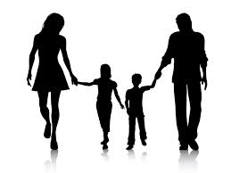
Diversity
We are all one!
