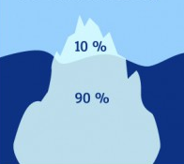
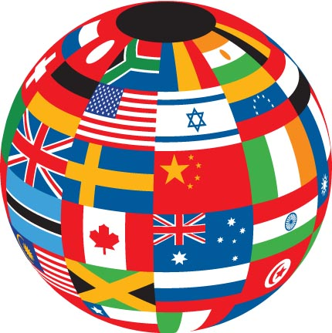

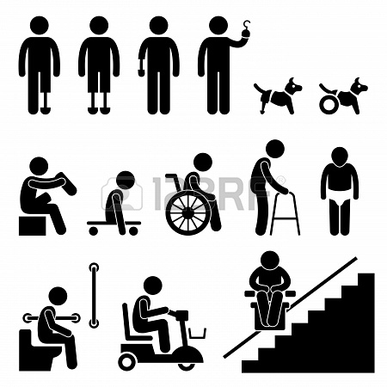

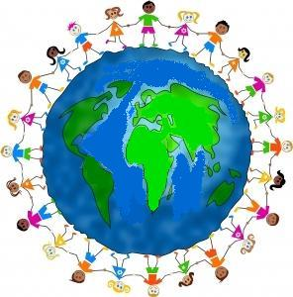

Picture sources:
Kids around the world- http://mus-iq.com/Small-World-Workshop.aspx
Iceberg number 1- http://blogs.denmark.dk/natalia/2012/06/03/the-danes-at-work/
Relgion- http://www.sobernation.com/religion-drug-use/
Ages- http://www.lsa.umich.edu/psych/diversity/
Hanidcap- http://www.123rf.com/photo_18911127_amputee-handicap-disable-people-man-tool-equipment-stick-figure-pictogram-icon.html
money- http://abcnews.go.com/topics/business/finance/unclaimed-money.htm
culture- http://ows.edb.utexas.edu/site/kimberly-nelligan/linguistic-and-cultural-diversity
marriage- http://www.cafepress.com/politicalbanner.249934937

